DESCRIPTION OF THE ASSIGNMENT

Search for monuments on Beardsley Road from former survey.

Cost of Services

Total Cost of Basic Services………….…... $ 200

Offer of Proposal

This proposal is hereby presented for acceptance by Client. It will remain valid for sixty (60) calendar days from the date first listed below. Alpha Land Surveying, Inc. reserves the right to modify the cost of services, or any term or condition of the proposal after such date.

Date: May 18, 2020
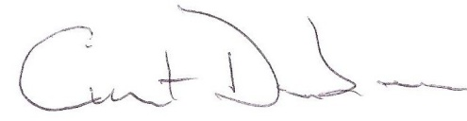
By: Curt G Dunbar, PLS 5615

Acceptance and Authorization to Proceed

The within proposal is hereby accepted and authorization is granted to Consultant to proceed with the services described under Tasks 1.0 above.

By: ____________________________________________ Date: May , 2020

Print: ____________________________________________

Mailing Address:___________________________________________________________

